 | Aditya College of Engineering and Technology
 | # 2/2, 2/8 & 2/9, Kamakshipura, Hesaraghatta Hobli, Yelahanka, Bengaluru – 560 089
 | Affiliated to VTU, Belagavi, Approved by UGC/AICTE/Govt. of Karnataka, Bengaluru
Department of Computer Science and Engineering
DATABASE MANAGEMENT SYSTEM LAB MANUAL
(BCS403)

1. Create a table called Employee & execute the following.
Employee(EMPNO,ENAME,JOB, MANAGER_NO, SAL, COMMISSION)
1. Create a user and grant all permissions to the user.
2. Insert the any three records in the employee table contains attributes EMPNO,ENAME JOB, MANAGER_NO, SAL, COMMISSION and use rollback. Check the result.
3. Add primary key constraint and not null constraint to the employee table.
4. Insert null values to the employee table and verify the result.
SOLUTION:
mysql>show databases;
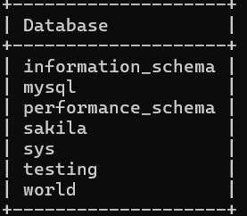
7 rows in set (0.07 sec)
mysql> create database vaishali;
Query OK, 1 row affected (0.04 sec)
mysql> show databases;
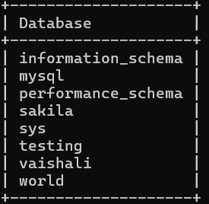
mysql> use vaishali;
Database changed
mysql> create table Employee(EMPNO int(12),ENAME char(12),JOB char(20),MANAGER_NO int(10),SAL dec(10,2),COMISSION dec(10,2));
Query OK, 0 rows affected, 2 warnings (0.06 sec)
mysql> desc Employee;
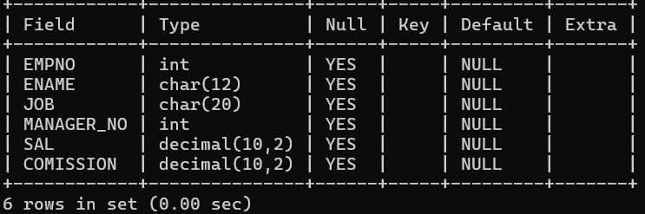
1. Create a user and grant all permissions to the user.
--Create user query
mysql> create user aditya;
Query OK, 0 rows affected (0.01 sec)

--Provide roles
mysql> GRANT ALL PRIVILEGES ON Employee to aditya;
Query OK, 0 rows affected (0.01 sec)
2. Insert the any three records in the employee table contains attributes EMPNO,ENAME JOB, MANAGER_NO, SAL, COMMISSION and use rollback. Check the result.
mysql> insert into Employee values (1234,'ullas','soft',7890,60200.54,10000.34),(2345,'punith','CA',8901,70200.24,15000.64),(3456,'kavin','police',9067,80200.74,5000.74);
Query OK, 3 rows affected (0.03 sec)
Records: 3 Duplicates: 0 Warnings: 0
mysql> select *from Employee;
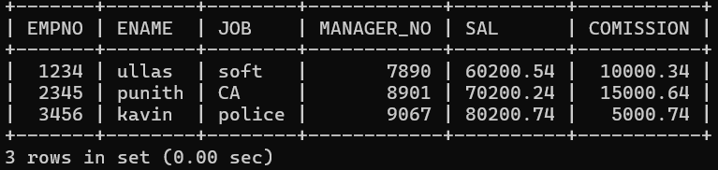

3. Add primary key constraint and not null constraint to the employee table.
mysql> alter table Employee add primary key(EMPNO,ENAME);
Query OK, 0 rows affected (0.13 sec)
Records: 0 Duplicates: 0 Warnings: 0
mysql> desc Employee;
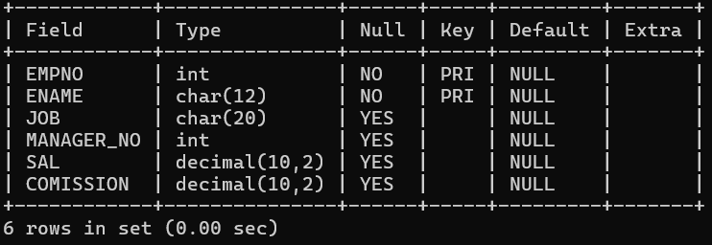
4. Insert null values to the employee table and verify the result.
mysql> insert into Employee values(null,null,null,null,null,null);
ERROR 1048 (23000): Column 'EMPNO' cannot be null

2. Create a table called Employee that contain attributes EMPNO,ENAME, JOB, MGR,SAL & execute the following.
1. Add a column commission with domain to the Employee table.
2. Insert any five records into the table.
3. Update the column details of job
4. Rename the column of Employee table using alter command.
5. Delete the employee whose Empno is 105.
SOLUTION:
mysql> create table employee1 (EMPNO int(10),ENAME char(12),JOB char(10),MGR int(15),SAL dec(10,2));
Query OK, 0 rows affected, 2 warnings (0.11 sec)
mysql> desc employee1; 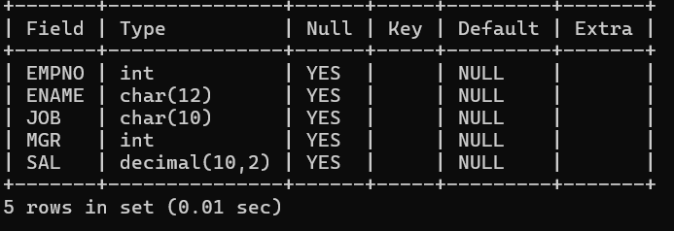

1. Add a column commission with domain to the Employee table.
mysql> alter table employee1 add (COMMISION dec(10,2));
Query OK, 0 rows affected (0.12 sec)
Records: 0 Duplicates: 0 Warnings: 0
mysql> desc employee;
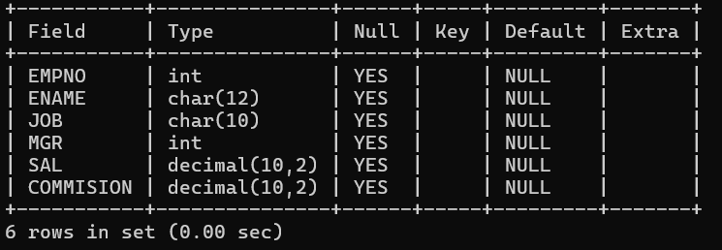

2. Insert any five records into the table.
mysql> insert into employee1 values(101,'abhi','manager',1234,10000.00,7000.32),(102,'ajay','soft',2341,30300.10,10000.52),(103,'raj','police',4123,60300.56,30400.62),(104,'jay','soft',4123,50300.56,10100.92),(105,'ram','doctor',5341,40300.60,20000.82);

Query OK, 5 rows affected (0.03 sec)
Records: 5 Duplicates: 0 Warnings: 0

mysql> select *from employee1;
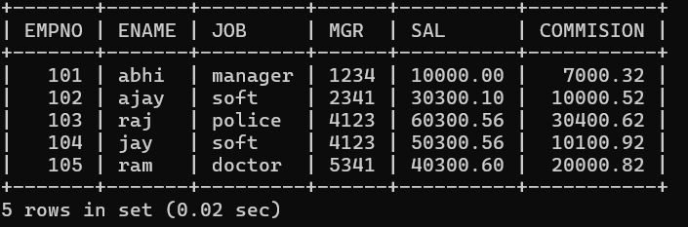
3. Update the column details of job

mysql> update employee1 set job='trainee' where EMPNO=103;
Query OK, 1 row affected (0.03 sec)
Rows matched: 1 Changed: 1 Warnings: 0

mysql> select *from employee1;
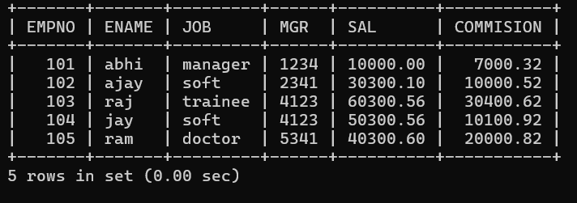
Update the remaining column details in job
4. Rename the column of Employee table using alter command.
mysql> alter table employee1 rename column MGR to MANAGER_NO;
Query OK, 0 rows affected (0.04 sec)
Records: 0 Duplicates: 0 Warnings: 0Table altered.
mysql> desc employee1;
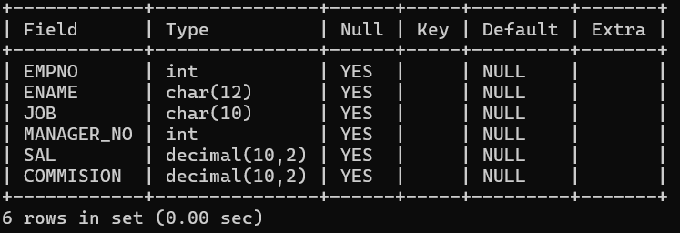

5.Delete the employee whose Empno is105.

mysql> delete from employee1 where EMPNO=105;
Query OK, 1 row affected (0.01 sec)
mysql> select *from employee1;
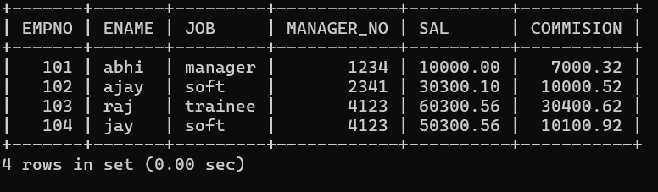

3.Queries using aggregate functions(COUNT,AVG,MIN,MAX,SUM),Group by,Orderby.
Employee(E_id, E_name, Age, Salary)
1. Create Employee table containing all Records E_id, E_name, Age, Salary.
2. Count number of employee names from employeetable
3. Find the Maximum age from employee table.
4. Find the Minimum age from employeetable.
5. Find salaries of employee in Ascending Order.
6. Find grouped salaries of employees.

1. Create Employee table containing all Records E_id, E_name, Age, Salary.
mysql> create table employee2(E_id int(10), E_name varchar(10),Age int(10),Salary dec(10,2));
Query OK, 0 rows affected, 2 warnings (0.14 sec)
mysql> desc employee2;
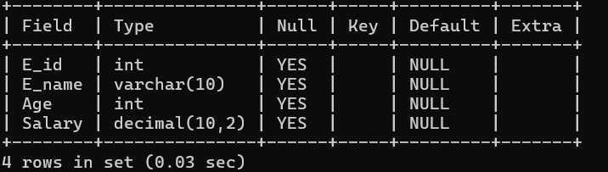

mysql> insert into employee2 values(123,'abhi',30,40000.45),(234,'puni',25,3000),(345,'gana',35,50000.34),(456,'ullasa',25,35000.22),(567,'kavin',30,45000.89);
Query OK, 5 rows affected (0.04 sec)
Records: 5 Duplicates: 0 Warnings: 0
mysql> select *from employee2;
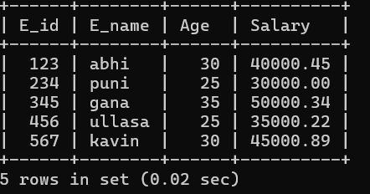
2. Count number of employee names from employee table.

mysql> select count(E_name) from employee2;
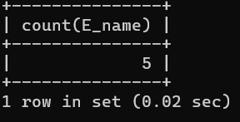
3. Find the Maximum age from employee table.
mysql> select max(age) from employee2;

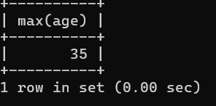

4. Find the Minimum age from employee table.
mysql> select min(age) from employee2;

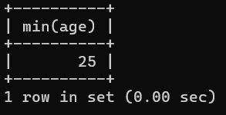

5. Find salaries of employee in Ascending Order.

mysql> select e_name,salary from employee2 order by salary;

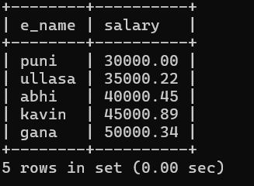

mysql> select *from employee2 order by salary;

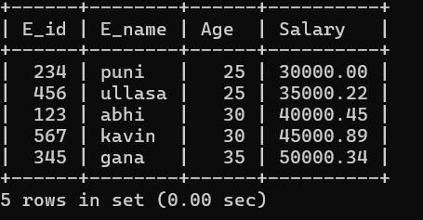

6. Find grouped salaries of employees.
mysql> select salary ,count(*) from employee2 group by salary;
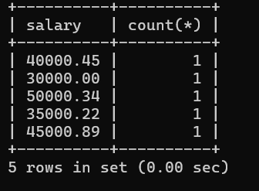

mysql> select e_name,salary from employee2 where salary>40000 group by e_name,salary;
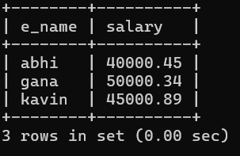
4. Create a row level trigger for the customers table that would fire for INSERT or UPDATE or DELETE operations performed on the CUSTOMERS table. This trigger will display the salary difference between the old & new Salary. CUSTOMERS(ID,NAME,AGE,ADDRESS,SALARY)

mysql>CREATE TABLE CUSTOMERS (
ID INT PRIMARY KEY,
NAME VARCHAR(50),
AGE INT,
ADDRESS VARCHAR(100),
SALARY DECIMAL(10,2)
);
mysql>INSERT INTO CUSTOMERS (ID, NAME, AGE, ADDRESS, SALARY)
VALUES (1, 'Alice', 30, 'Bangalore', 5000),(2, 'Bob', 40, 'Mumbai', 6000),(3,'john',40,'delhi',7000),(4,'smith',30,'kerala',8000);

mysql> select * from customers;
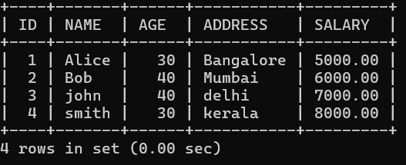

mysql> CREATE TABLE salary_log (
log_id INT AUTO_INCREMENT PRIMARY KEY,
action_type VARCHAR(10),
old_salary DECIMAL(10,2),
new_salary DECIMAL(10,2),
salary_diff DECIMAL(10,2),
log_time TIMESTAMP DEFAULT CURRENT_TIMESTAMP
);
Query OK, 0 rows affected (0.02 sec)

mysql> DELIMITER //
mysql> CREATE TRIGGER trg_salary_insert
AFTER INSERT ON CUSTOMERS
FOR EACH ROW
BEGIN
INSERT INTO salary_log(action_type, old_salary, new_salary, salary_diff)
VALUES('INSERT', NULL, NEW.SALARY, NULL);
END;
//
Query OK, 0 rows affected (0.01 sec)
mysql> CREATE TRIGGER trg_salary_update
AFTER UPDATE ON CUSTOMERS
FOR EACH ROW
BEGIN
INSERT INTO salary_log(action_type, old_salary, new_salary, salary_diff)
VALUES('UPDATE', OLD.SALARY, NEW.SALARY, NEW.SALARY - OLD.SALARY);
END;
//
Query OK, 0 rows affected (0.01 sec)

mysql> CREATE TRIGGER trg_salary_delete
AFTER DELETE ON CUSTOMERS
FOR EACH ROW
BEGIN
INSERT INTO salary_log(action_type, old_salary, new_salary, salary_diff)
VALUES('DELETE', OLD.SALARY, NULL, NULL);
END;
//
Query OK, 0 rows affected (0.01 sec)

mysql> DELIMITER ;

mysql> UPDATE CUSTOMERS SET SALARY = 7000 WHERE ID = 1;
Query OK, 1 row affected (0.01 sec)
Rows matched: 1 Changed: 1 Warnings: 0
mysql> SELECT * FROM salary_log;

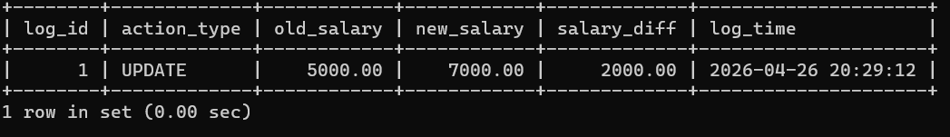

5. Create cursor for Employee table & extract the values from the table. Declare the variables , Open the cursor & extract the values from the cursor. Close the cursor. Employee (E_id, E_name, Age, Salary)
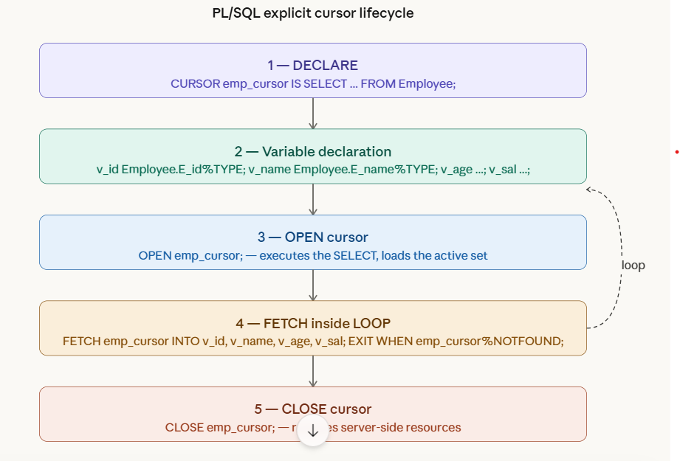

mysql> CREATE TABLE Employee (
E_id INT(10) PRIMARY KEY,
E_name VARCHAR(50),
Age INT,
Salary DECIMAL(10,2)
);
Query OK, 0 rows affected (0.04 sec)

mysql> INSERT INTO Employee VALUES (1, 'Alice', 28, 55000.00);
Query OK, 1 row affected (0.00 sec)

mysql> INSERT INTO Employee VALUES (2, 'Bob', 34, 72000.00);
Query OK, 1 row affected (0.01 sec)

mysql> INSERT INTO Employee VALUES (3, 'Charlie', 25, 48000.00);
Query OK, 1 row affected (0.00 sec)

mysql> INSERT INTO Employee VALUES (4, 'Diana', 31, 63000.00);
Query OK, 1 row affected (0.00 sec)

mysql> INSERT INTO Employee VALUES (5, 'Evan', 40, 91000.00);
Query OK, 1 row affected (0.00 sec)
mysql> select *from empoyee;
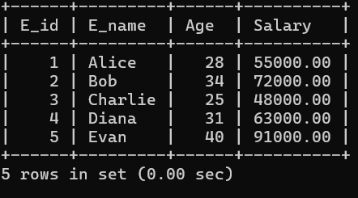

mysql> DELIMITER $$

CREATE PROCEDURE fetch_employees3()
BEGIN
-- 1. Declare variables to hold fetched values
DECLARE v_E_id INT;
DECLARE v_E_name VARCHAR(100);
DECLARE v_Age INT;
DECLARE v_Salary DECIMAL(10,2);

-- Flag to detect end of cursor
DECLARE done INT DEFAULT 0;

-- 2. Declare the cursor
DECLARE emp_cursor CURSOR FOR
SELECT E_id, E_name, Age, Salary
FROM Employee;

-- 3. Declare continue handler (sets done=1 when no more rows)
DECLARE CONTINUE HANDLER FOR NOT FOUND SET done = 1;

-- 4. Open the cursor
OPEN emp_cursor;

-- 5. Fetch loop
fetch_loop: LOOP
FETCH emp_cursor INTO v_E_id, v_E_name, v_Age, v_Salary;

-- Exit when no more rows
IF done = 1 THEN
LEAVE fetch_loop;
END IF;

-- Display the extracted values
SELECT v_E_id AS Employee_ID,
v_E_name AS Employee_Name,
v_Age AS Age,
v_Salary AS Salary;
END LOOP fetch_loop;

-- 6. Close the cursor
CLOSE emp_cursor;

END $$

mysql> DELIMITER ;
-- Call the procedure
mysql> CALL fetch_employees3();

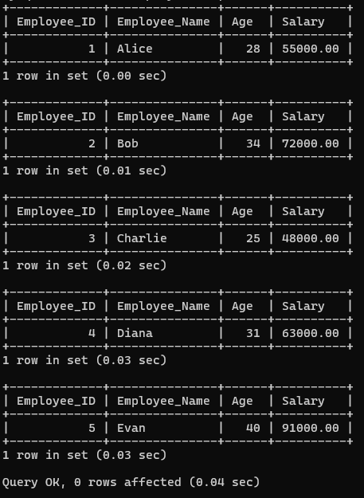

6. Write a PL/SQL block of code using parameterized Cursor, that will merge the data available in the newly created table N_RollCall with the data available in the table O_RollCall. If the data in the first table already exist in the second table then that data should be skipped.

mysql> CREATE TABLE N_RollCall (
roll_no INT,
name VARCHAR(50),
attendance_date DATE
);
Query OK, 0 rows affected (0.10 sec)
mysql> CREATE TABLE O_RollCall (
roll_no INT PRIMARY KEY,
name VARCHAR(50),
attendance_date DATE
);
Query OK, 0 rows affected (0.04 sec)
mysql> INSERT INTO N_RollCall VALUES
(1, 'Asha', '2026-05-01'),
(2, 'Ravi', '2026-05-01'),
(3, 'Neha', '2026-05-01');
Query OK, 3 rows affected (0.03 sec)
Records: 3 Duplicates: 0 Warnings: 0
mysql->DELIMITER //
CREATE PROCEDURE merge_rollcall()
BEGIN
DECLARE done INT DEFAULT 0;
DECLARE v_roll_no INT;
DECLARE v_name VARCHAR(50);
DECLARE v_attendance_date DATE;
DECLARE v_count INT;
-- Cursor for new table
DECLARE cur_new CURSOR FOR
SELECT roll_no, name, attendance_date
FROM N_RollCall;

DECLARE CONTINUE HANDLER FOR NOT FOUND SET done = 1;
OPEN cur_new;
read_loop: LOOP
FETCH cur_new INTO v_roll_no, v_name, v_attendance_date;
IF done = 1 THEN
LEAVE read_loop;
END IF;
-- Parameterized check using variable v_roll_no
SELECT COUNT(*)
INTO v_count
FROM O_RollCall
WHERE roll_no = v_roll_no;
IF v_count = 0 THEN
INSERT INTO O_RollCall(roll_no, name, attendance_date)
VALUES(v_roll_no, v_name, v_attendance_date);
END IF;
END LOOP;
CLOSE cur_new;
END //
Query OK, 0 rows affected (0.18 sec)
mysql>
mysql> DELIMITER ;
mysql> CALL merge_rollcall();
Query OK, 0 rows affected (0.03 sec)
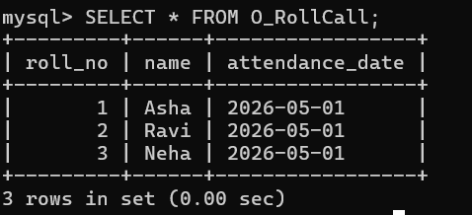

7. Install an Open Source NoSQL Data base Mango DB & perform basic CRUD(Create, Read, Update & Delete) operations. Execute Mango DB basic Queries using CRUD operations.

